**NAME:KUSHAL SHAH**

**STUDENT ID:A20207420**

**EMAIL ID:kusshah@okstate.edu**

**Ans:1)**

**A)**

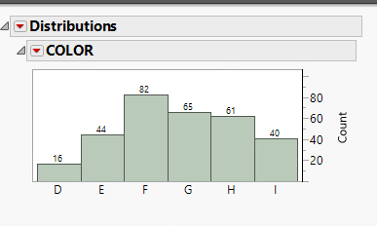 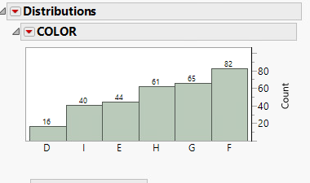

Above two figure shows horizontal bar chart with frequency distribution for each category of colour with right figure shows bars by ascending count

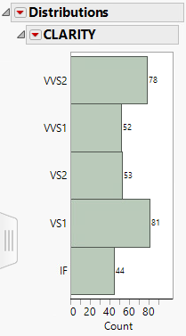 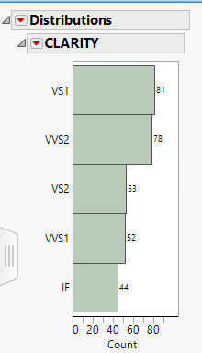

Above two figure shows Vertical bar chart with frequency distribution for each category for Clarity with right figure shows bars by ascending count

**B)**

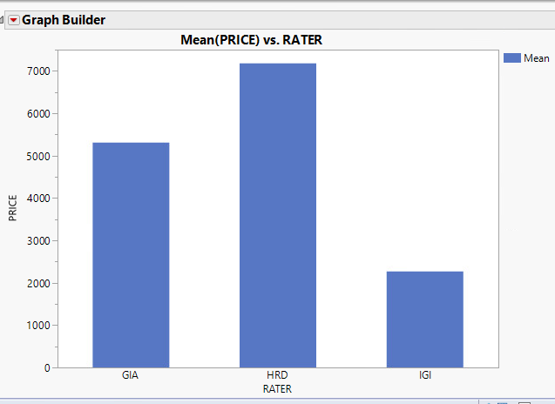

Above graph shows vertical bar chart Rater(X) by price(Y) ensuring price is mean price.

ANS-2)

**A)**  **B)**

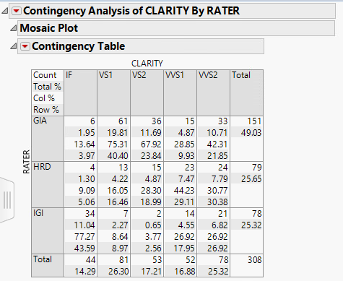 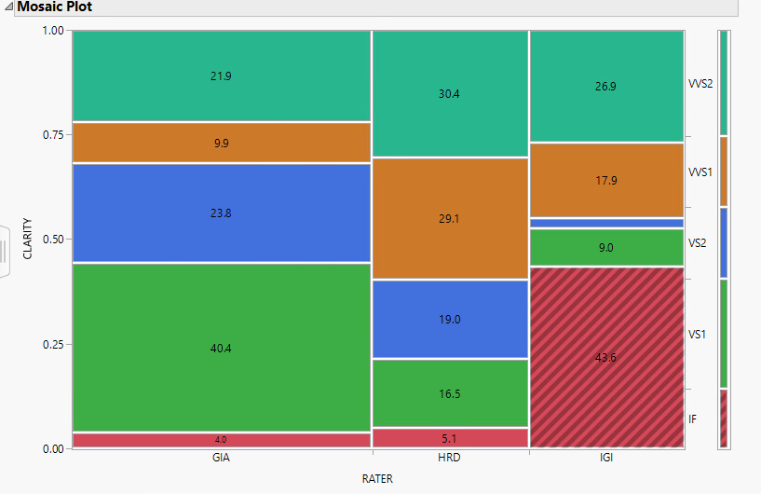

Above figure shows contingency table for clarity Above table shows Mosaic Plot for clarity by Rater with

By Rater with count, col%, Row% percentage display.

**ANS-3)**

**A)**

Null hypothesis(H0): Mean of Price variable in data is same as Market price of diamond($4000)

Alternative Hypothesis(Ha): (Mean price is not equal to $4000)

**B)**

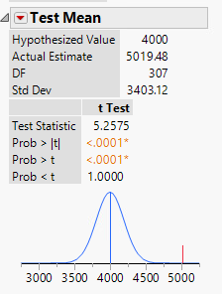 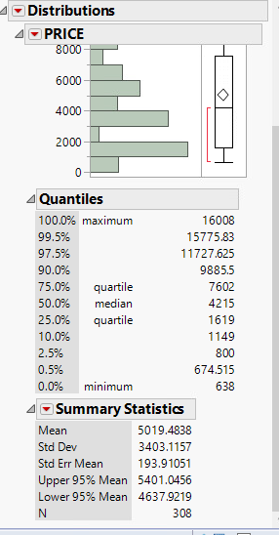

If we test hypothesized mean value($40000) with actual estimate, then we can see that prob>|t| is actually less that 0.0001.

Comparing that with standard significance level(0.05), we can say that we can actually reject null hypothesis.

Red line in right most side of chart(if mean of price were $4000) suggest that price in data set is over market average price. It

Can be shown from price distribution upper 95% mean and lower 95% mean from $4637.9219 to $5401.0456 that market

Average price is lower than price data.

**C)**

Looking at the data, we get actual insight of what is there. We can determine that Mean value of diamonds in data set is

Is 25% more that Market Price. In this case, I would suggest manager to first check the total profit margin and sell value.

Then I would suggest him to forecast total diamond sell at different reduced mean price,which still can make sustainable

profit. If we can make more profit at any reduced price than current profit(by creating more sell), then I would suggest

manager to adjust prices of diamonds in such a way that it brings average value of diamonds to decided mean value. In contrast, if we cannot find any reduced mean value of diamond prices at which we make more profit then current profit, then I would advise manager to go with the current prices.

**ANS-4)**

**GIA compare to HRD**

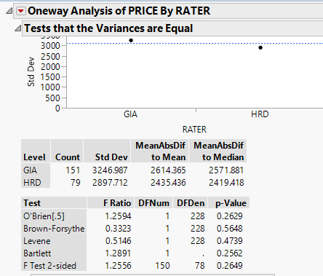 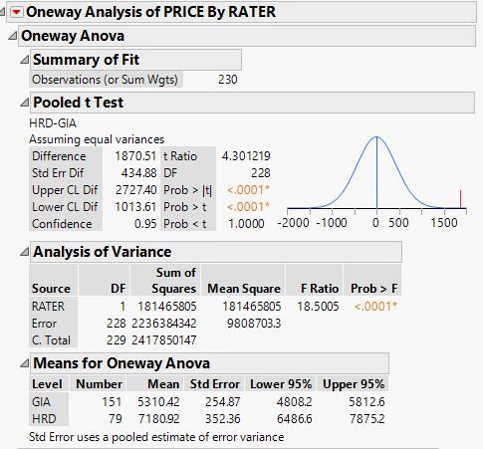

In comparison of Price by RATER(GIA,HRD), equal variance test shows P value of 0.2649(F test-2 sided). Comparing that with

standard value of 0.05, we can state variance in price of diamond by two Rater GIA and HRD is same. For Equal variance, we can determine

difference between mean value of price of diamond by GIA and HRD by pooled t test. Prob>|t| equal to <0.0001 in right side of

above figure suggest that there is difference in average of price for category GIA and HRD. Mean price for HRD($7180.92)

w.r.t mean price for GIA($5310.42) suggest that GIA rater is undervaluing diamond price compare to HRD

**GIA compare to IGI**

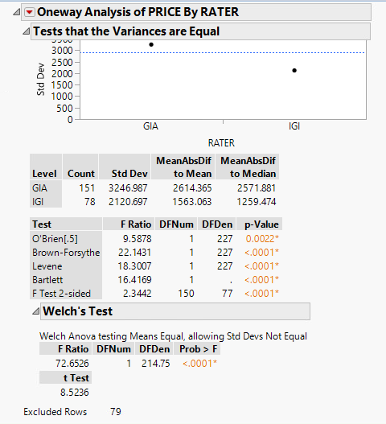 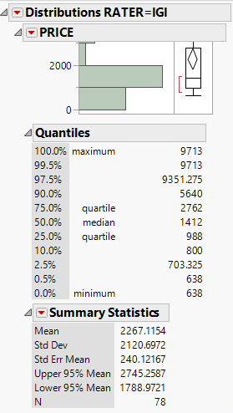

In comparison of Price by RATER(GIA,IGI), equal variance test shows P value of <0.0001(F test-2 sided). Comparing that with

standard value of 0.05, we can state variance in price by two Rater GIA and IGI is not same. For Unequal variance, we can determine equivalence in mean value of price by Rater GIA and IGI by weltch test. Prob>F equal to <0.0001 in welch test suggest that there is difference in average of price of diamond given by GIA and IGI. Mean price for IGI($2267.1154)

w.r.t mean price for GIA($5310.42) suggest that IGI rater is undervaluing diamond price compare to GIA

1. Above finding shows that, there is a considerable difference in mean price of diamond by RATER HRD, GIA, IGI. Trend shows that mean value of price is highest by HRD, second highest by IGI and lowest by IGI. This suggest that, Manager’s concern is true regarding undervaluation. IGI Rater out of 3 is undervaluing diamond’s price most after GIA.

Suggestion: Based on this, I would recommend Manager to re-evaluate diamonds which had been evaluated by IGI Rater from either HRD or GIA Rater.

---

**Ans-5)**

In answer-3, We did one sample T-test to check estimated mean value of price with hypothesized mean value of prize.

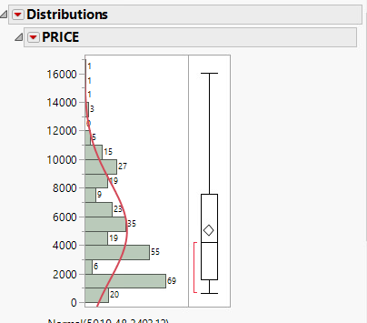

**A)**

Variable-price is a continuous variable and all observations are independent

From the histogram we can conclude that, Price variable is not normally distributed. It also contains outliers.

Conclusion: This means that not all of 4 requirements for one sample T-test has been fulfilled by Price variable. That means that above analysis in ANS 3 does not meet all of the assumption.

1. My Response would change based on these assumption because these assumption proves that One sample T-test is not reliable for Price Variable